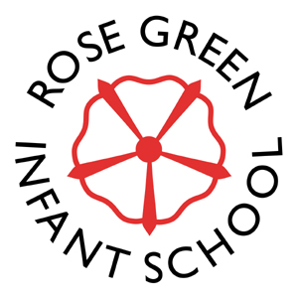
Rose Green Infant School
Hawkins Close
Bognor Regis
West Sussex
PO21 3LW

Tel & Fax: 01243 262318

Email: office@rosegreeninfant.school Website: www.rosegreeninfant.school

20th February 2023

Dear Reception Parents/Carers

As part of our EYFS reading curriculum, we have arranged for the Reception classes to visit Willowhale library on Thursday 16th March. We want to introduce some children to the library and continue to nurture a love of reading for all. The classes will be visiting the library at the following times:-

- Poppy Class: 10.00 – 10.45 am
- Bluebell Class: 11.00 – 11.45 am
- Sunflower Class 1.30 – 2.15 pm

I attach a copy of a letter from the Library service inviting your child to join the library if they are not already a member. Please can you return this form to us by no later than Monday 6th March so that the library staff have time to prepare any library cards requested. If your child already has a library card, there is no need for you to complete this form but please ensure they bring their card with them on their visit.

If any parent is able to help with walking to the library, please can you contact your child’s teacher.

Many thanks

Mrs Bennett, Miss Beeney, Mrs Dawson-Pollitt & Mrs McGahey
Reception Teachers

